Mary Walters

Game Pad Concept Development

The Impossible Journey

My game is an adventure game where the user must solve a series of riddles and challenges based on completely random, illogical, and weird concepts. The idea is kind of a combination of the Impossible Quiz and an escape room. The player will travel through a series of rooms collecting items, interacting with other characters, and dodging other obstacles. They must find the key to move on to the next room. Each room is totally different and random compared to the last.

References

1. The Impossible Quiz

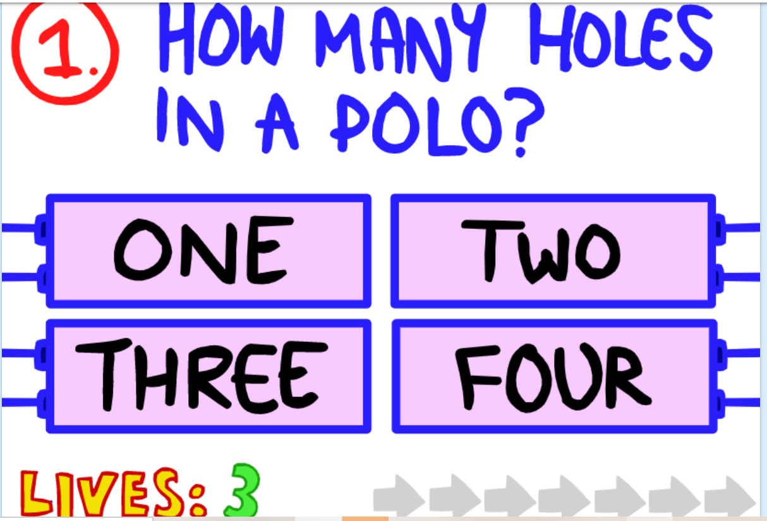

The impossible quiz is a serious of ridiculous, illogical questions that don’t make any sense. It consistently tricks you and makes you feel stupid. This makes you want to beat it even more so you continue to work through the questions by memorizing the answers until you look up and you’ve accidently been doing it for an hour. The general concept of an ultra-confusing, stupid game is what I am trying to mimic in The Impossible Journey

1. Stardew Valley

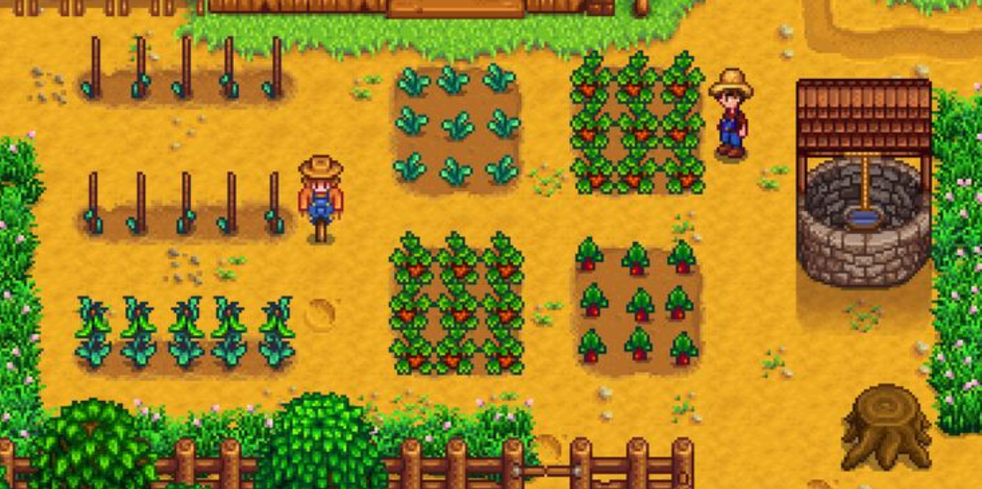

This game is similar to how I envision the top-down view and layout of my game. The simple animation and colors are elements I like. The entrances and exits into the screen are also something I want to replicate.

1. Blue House

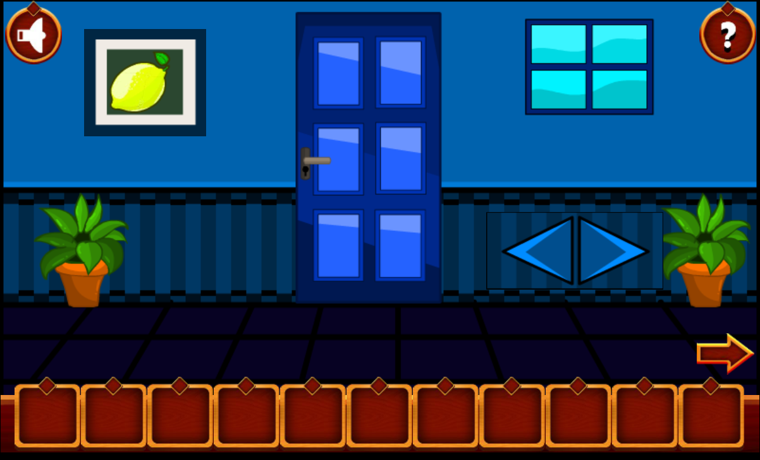

Blue House is an escape room game where the user must figure out how to advance. The concept of a series of rooms with challenges is another thing I am trying to replicate. The user has tools to use to help them and they collect more as they go. This is something else I like.

Characters

Hero: Spongebob?

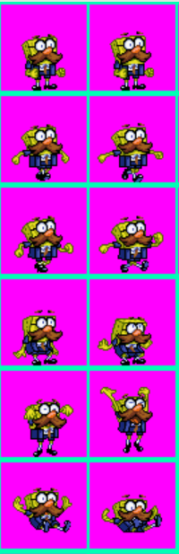

Helper: clippit

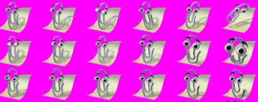

Villain: Cinderella

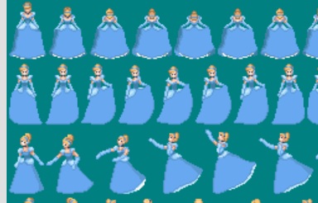

Level Template idea

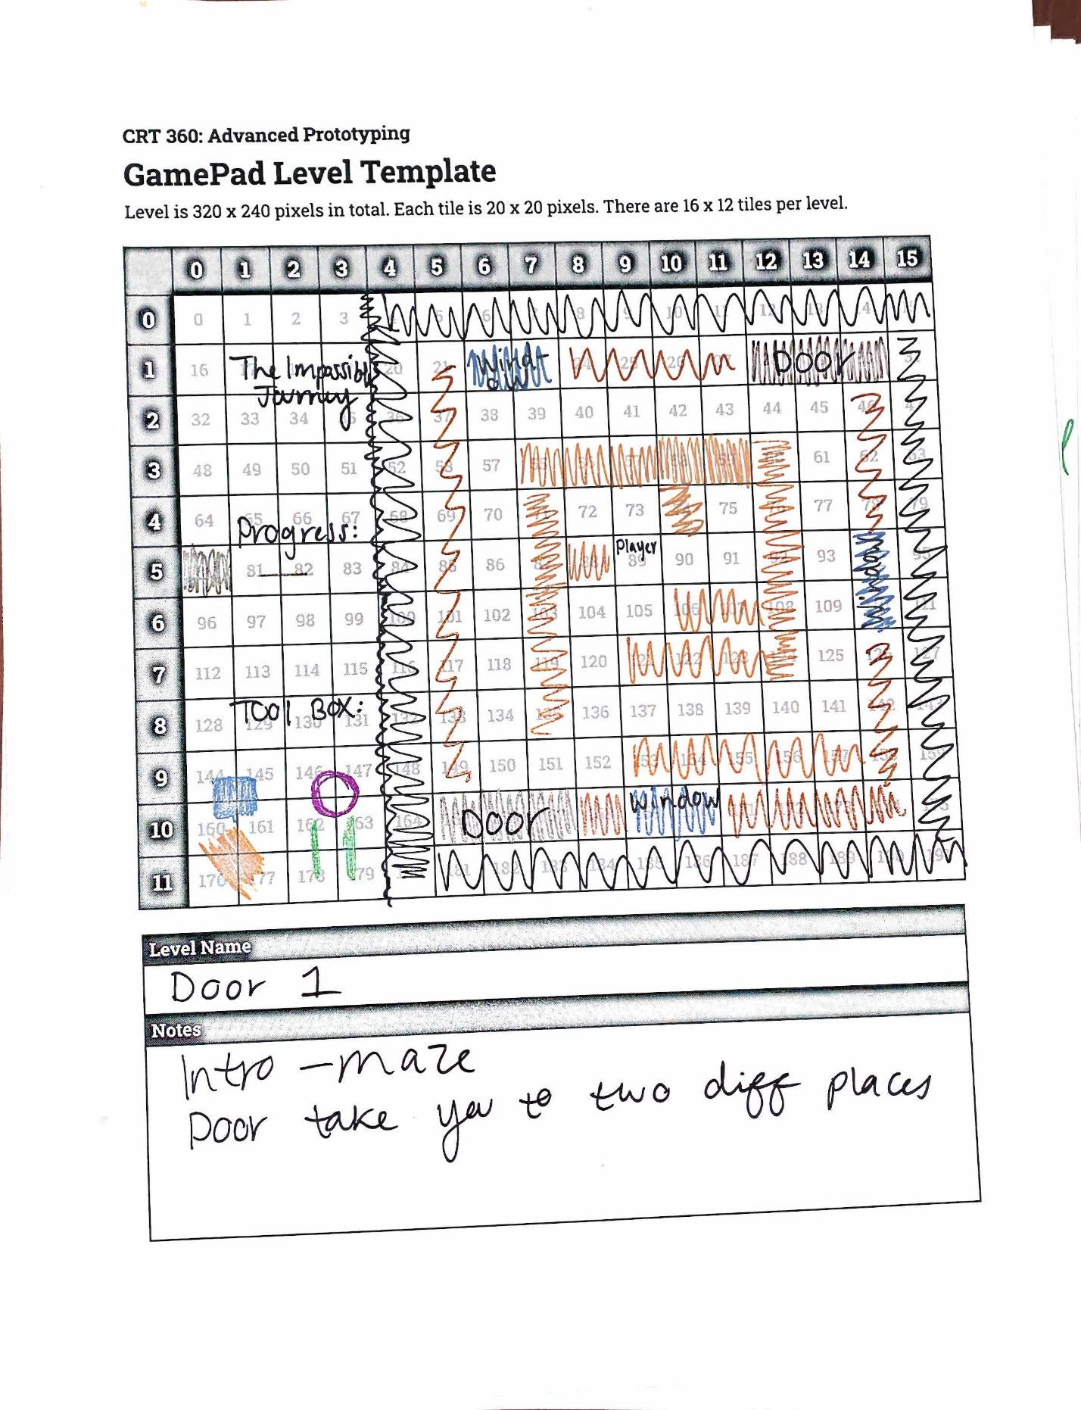

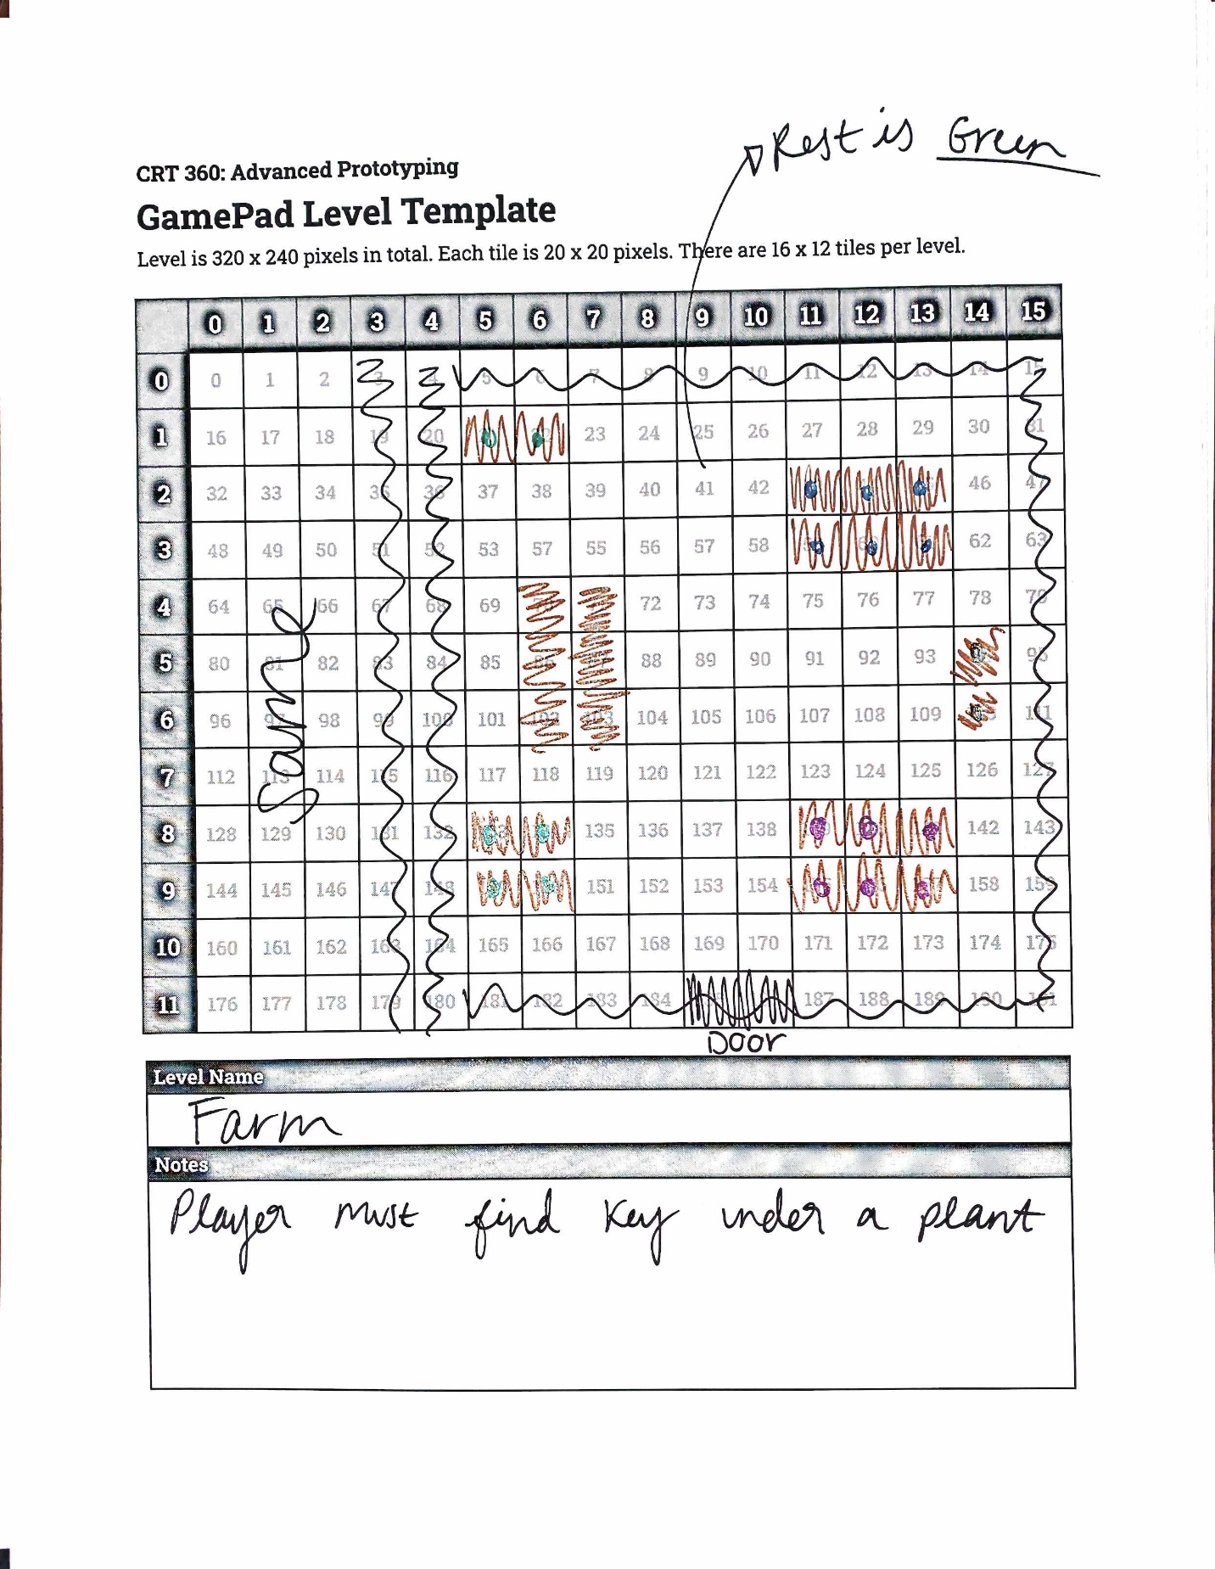

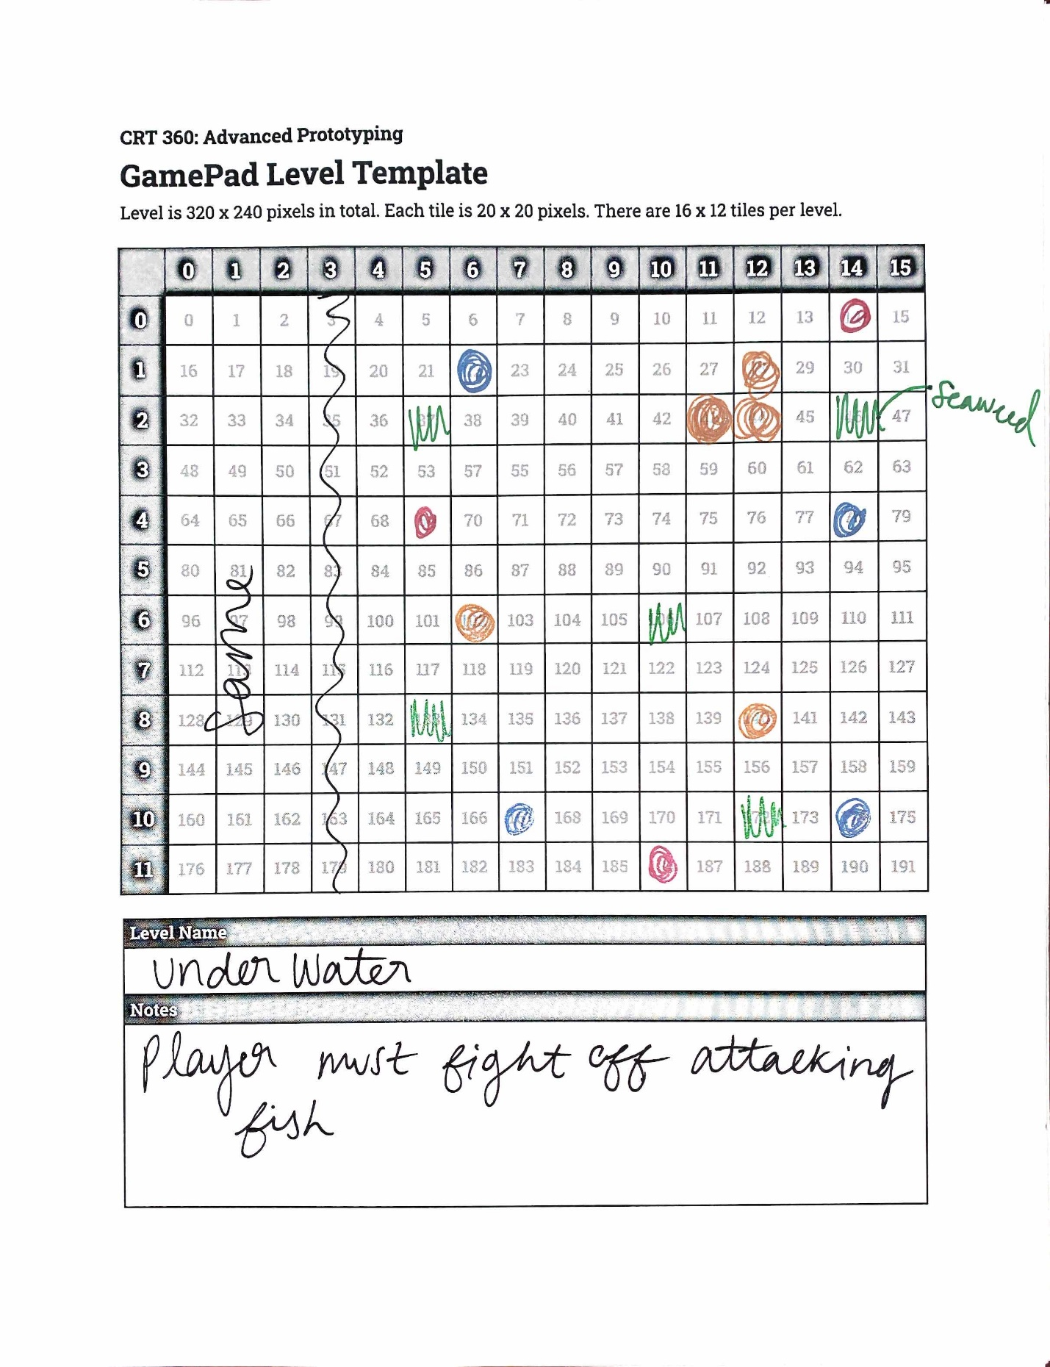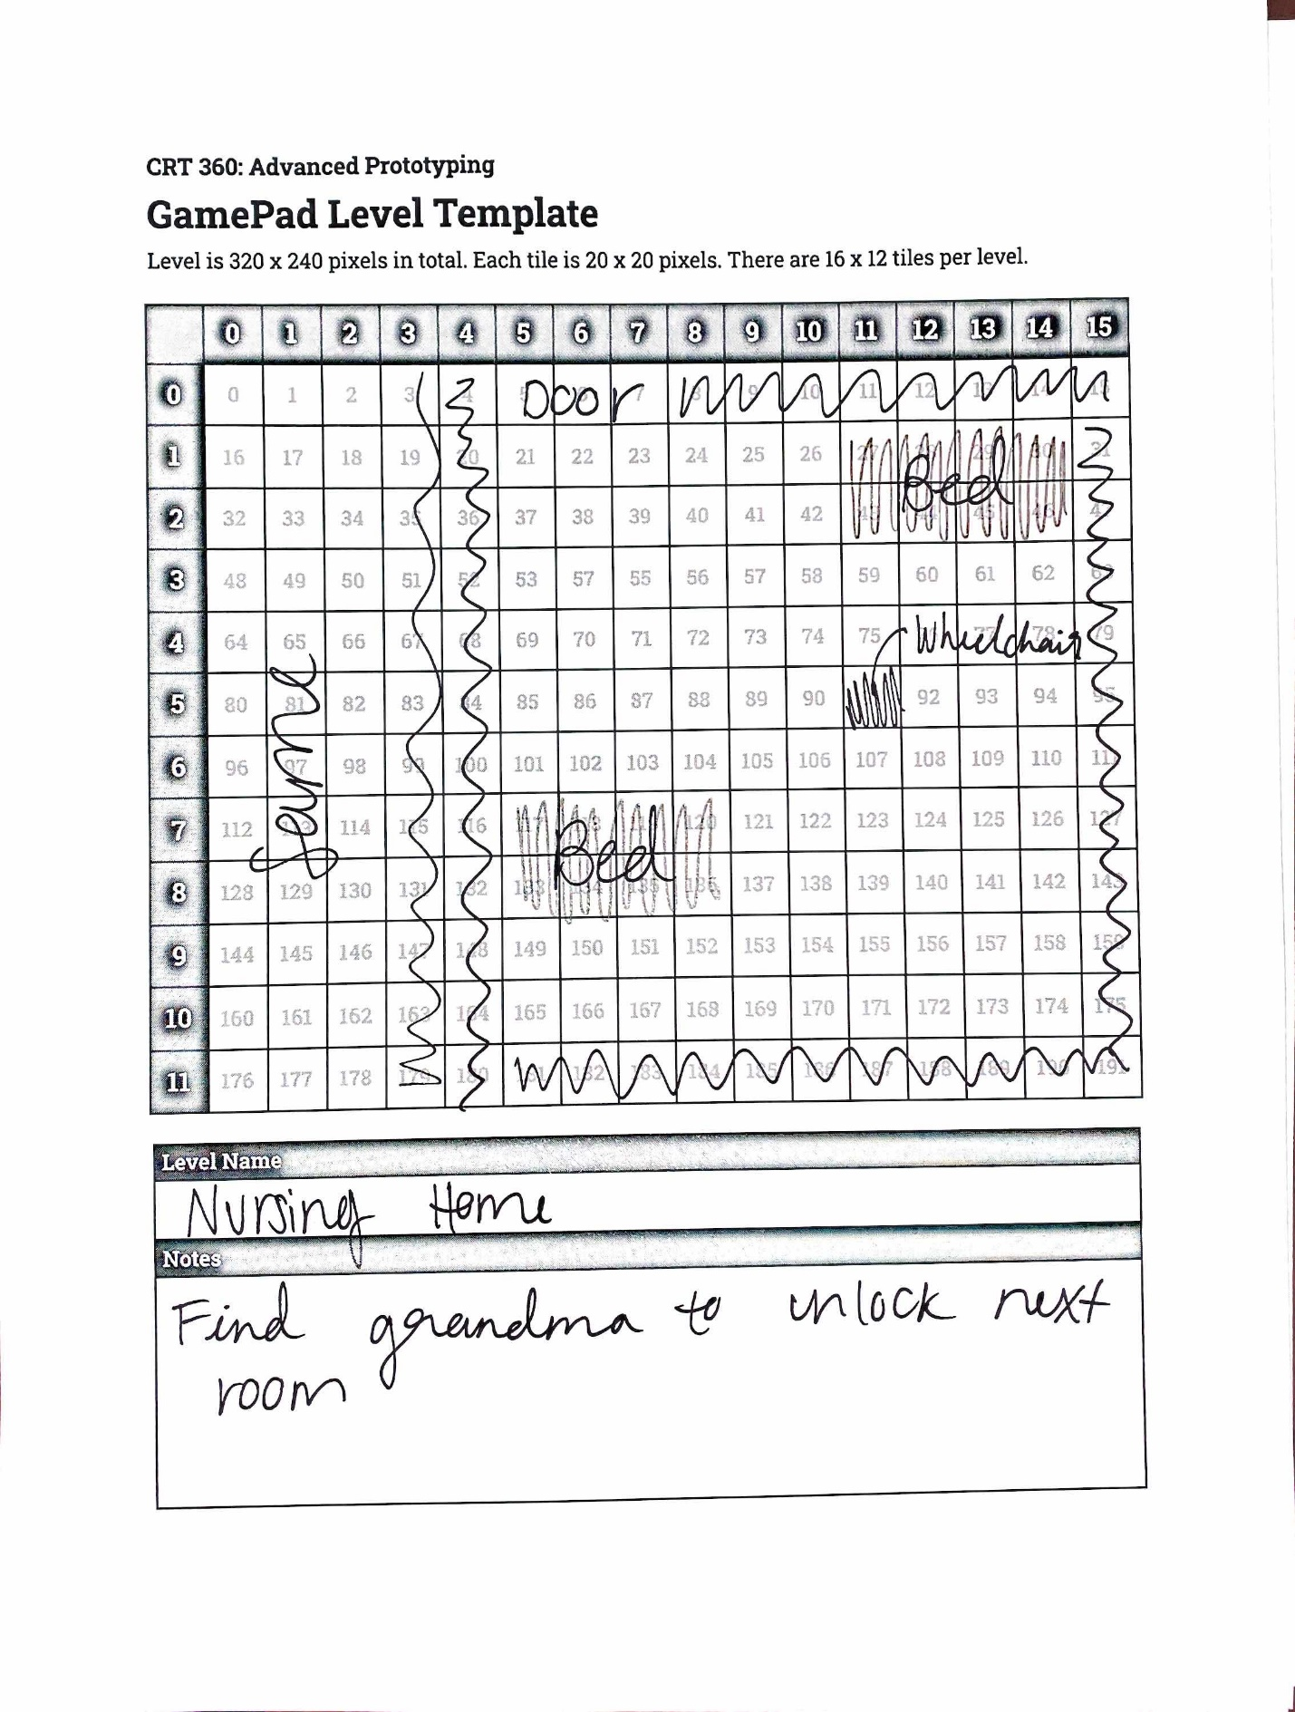

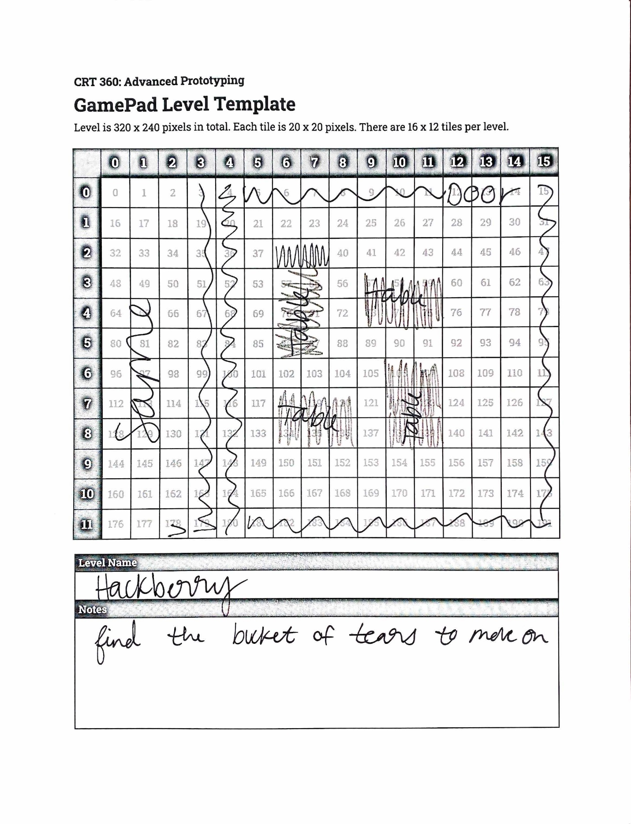

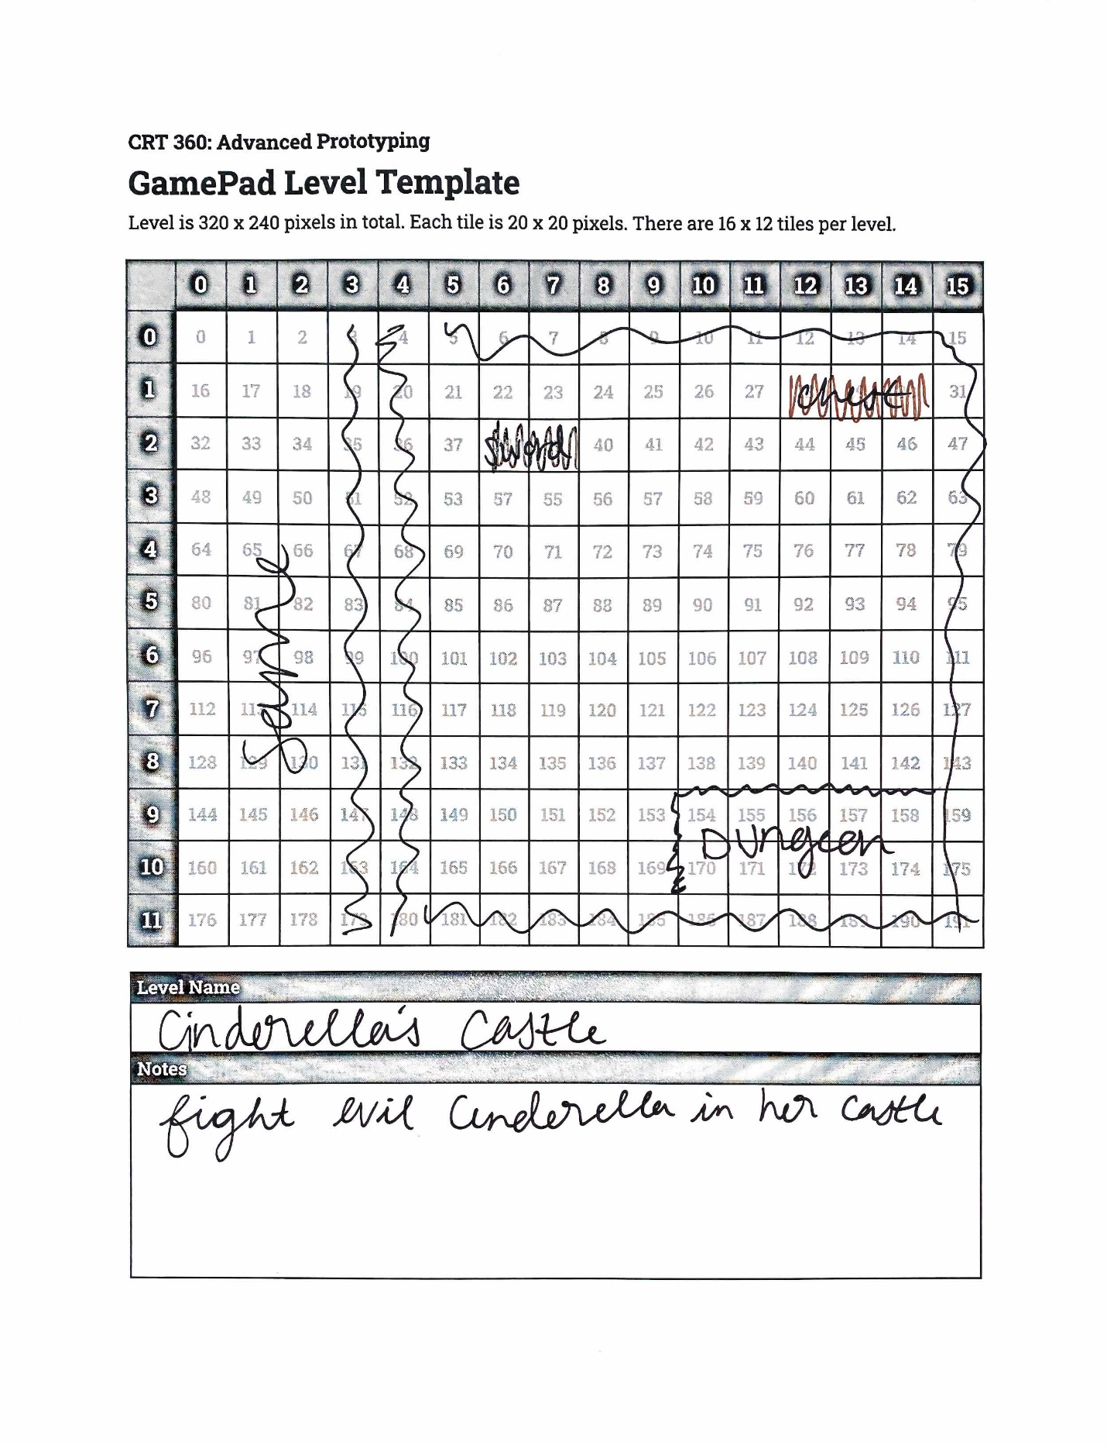

|  |  |
| --- | --- |
| **Controller Interactions** | |
| Joystick X | Moves the user horizontally across the screen. |
| Joystick Y | Moves the user vertically across the screen. |
| Button A | Interacts with objects in the room (doors, items, etc.) |
| Button B | Shoots enemies |
| Button C | Uses tools in tool box |
| Button D | Use a skip/help |